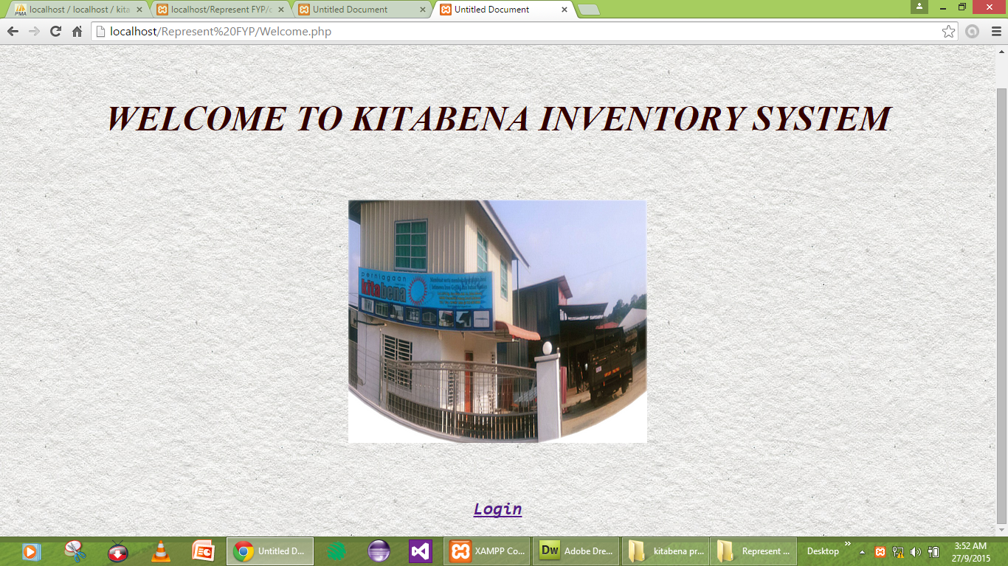

Welcome

<!DOCTYPE html PUBLIC "-//W3C//DTD XHTML 1.0 Transitional//EN" "http://www.w3.org/TR/xhtml1/DTD/xhtml1-transitional.dtd">

<html xmlns="http://www.w3.org/1999/xhtml">

<head>

<meta http-equiv="Content-Type" content="text/html; charset=utf-8" />

<title>Untitled Document</title>

<style type="text/css">

<!--

.WELCOME {

color: #0000A0;

}

body,td,th {

color: #0FF;

font-size: 24px;

font-family: Times New Roman, Times, serif;

font-style: italic;

}

body {

background-color: #FFF;

background-image: url(../images%20(6)

.jpg);

background-repeat: repeat;

color: #F00;

background-image: url(003-subtle-light-pattern-background-texture-vol51.jpg);

font-size: 24px;

}

.WELCOME .WELCOME strong {

color: #003;

}

.WELCOME h1 {

color: #303;

}

.WELCOME h2 kbd samp a strong {

color: #500;

}

.WELCOME h1 strong {

color: #300;

}

.WELCOME p kbd samp a strong {

font-size: 36px;

}

.WELCOME p kbd samp a strong {

font-size: 32px;

}

.WELCOME p kbd samp a strong {

font-size: 24px;

}

-->

</style>

<script type="text/javascript">

<!--

function MM_preloadImages() { //v3.0

var d=document; if(d.images){ if(!d.MM_p) d.MM_p=new Array();

var i,j=d.MM_p.length,a=MM_preloadImages.arguments; for(i=0; i<a.length; i++)

if (a[i].indexOf("#")!=0){ d.MM_p[j]=new Image; d.MM_p[j++].src=a[i];}}

}

function MM_findObj(n, d) { //v4.01

var p,i,x; if(!d) d=document; if((p=n.indexOf("?"))>0&&parent.frames.length) {

d=parent.frames[n.substring(p+1)].document; n=n.substring(0,p);}

if(!(x=d[n])&&d.all) x=d.all[n]; for (i=0;!x&&i<d.forms.length;i++) x=d.forms[i][n];

for(i=0;!x&&d.layers&&i<d.layers.length;i++) x=MM_findObj(n,d.layers[i].document);

if(!x && d.getElementById) x=d.getElementById(n); return x;

}

function MM_nbGroup(event, grpName) { //v6.0

var i,img,nbArr,args=MM_nbGroup.arguments;

if (event == "init" && args.length > 2) {

if ((img = MM_findObj(args[2])) != null && !img.MM_init) {

img.MM_init = true; img.MM_up = args[3]; img.MM_dn = img.src;

if ((nbArr = document[grpName]) == null) nbArr = document[grpName] = new Array();

nbArr[nbArr.length] = img;

for (i=4; i < args.length-1; i+=2) if ((img = MM_findObj(args[i])) != null) {

if (!img.MM_up) img.MM_up = img.src;

img.src = img.MM_dn = args[i+1];

nbArr[nbArr.length] = img;

} }

} else if (event == "over") {

document.MM_nbOver = nbArr = new Array();

for (i=1; i < args.length-1; i+=3) if ((img = MM_findObj(args[i])) != null) {

if (!img.MM_up) img.MM_up = img.src;

img.src = (img.MM_dn && args[i+2]) ? args[i+2] : ((args[i+1])? args[i+1] : img.MM_up);

nbArr[nbArr.length] = img;

}

} else if (event == "out" ) {

for (i=0; i < document.MM_nbOver.length; i++) {

img = document.MM_nbOver[i]; img.src = (img.MM_dn) ? img.MM_dn : img.MM_up; }

} else if (event == "down") {

nbArr = document[grpName];

if (nbArr)

for (i=0; i < nbArr.length; i++) { img=nbArr[i]; img.src = img.MM_up; img.MM_dn = 0; }

document[grpName] = nbArr = new Array();

for (i=2; i < args.length-1; i+=2) if ((img = MM_findObj(args[i])) != null) {

if (!img.MM_up) img.MM_up = img.src;

img.src = img.MM_dn = (args[i+1])? args[i+1] : img.MM_up;

nbArr[nbArr.length] = img;

} }

}

//-->

</script>

</head>

<body onload="MM_preloadImages('untitled.jpg','IMG-20150122-WA0000.jpg')">

<div align="center" class="WELCOME">

<h1>&nbsp;</h1>

<h1><strong>WELCOME TO KITABENA INVENTORY SYSTEM</strong> </h1>

<p>&nbsp;</p>

<p><a href="javascript:;" target="_top" onclick="MM_nbGroup('down','group1','IMG6219','untitled.jpg',1)" onmouseover="MM_nbGroup('over','IMG6219','IMG-20150122-WA0000.jpg','',1)" onmouseout="MM_nbGroup('out')"><img src="IMG_6219.jpg" alt="" name="IMG6219" width="405" height="330" border="0" align="texttop" id="IMG6219" onload="" /></a> </p>

<p>&nbsp;</p>

<p><kbd><samp><a href="Login3.php" target="_top"><strong>Login</strong></a></samp></kbd><a href="Login3.php"><strong></strong></a></p>

</div>

<center>

</body>

</html>

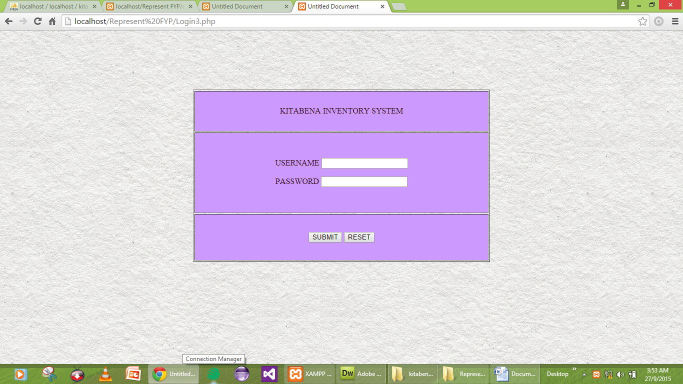

Login

<?php require_once('C:/xampp/htdocs/Kitabena_Project/kitabena project/Connections/Kitabenaconnnection.php'); ?>

<?php

if (!function_exists("GetSQLValueString")) {

function GetSQLValueString($theValue, $theType, $theDefinedValue = "", $theNotDefinedValue = "")

{

if (PHP_VERSION < 6) {

$theValue = get_magic_quotes_gpc() ? stripslashes($theValue) : $theValue;

}

$theValue = function_exists("mysql_real_escape_string") ? mysql_real_escape_string($theValue) : mysql_escape_string($theValue);

switch ($theType) {

case "text":

$theValue = ($theValue != "") ? "'" . $theValue . "'" : "NULL";

break;

case "long":

case "int":

$theValue = ($theValue != "") ? intval($theValue) : "NULL";

break;

case "double":

$theValue = ($theValue != "") ? doubleval($theValue) : "NULL";

break;

case "date":

$theValue = ($theValue != "") ? "'" . $theValue . "'" : "NULL";

break;

case "defined":

$theValue = ($theValue != "") ? $theDefinedValue : $theNotDefinedValue;

break;

}

return $theValue;

}

}

?>

<?php

// *** Validate request to login to this site.

if (!isset($_SESSION)) {

session_start();

}

$loginFormAction = $_SERVER['PHP_SELF'];

if (isset($_GET['accesscheck'])) {

$_SESSION['PrevUrl'] = $_GET['accesscheck'];

}

if (isset($_POST['textfield'])) {

$loginUsername=$_POST['textfield'];

$password=$_POST['textfield2'];

$MM_fldUserAuthorization = "";

$MM_redirectLoginSuccess = "Success.php";

$MM_redirectLoginFailed = "Fail2.php";

$MM_redirecttoReferrer = false;

mysql_select_db($database_Kitabenaconnnection, $Kitabenaconnnection);

$LoginRS__query=sprintf("SELECT username, password FROM login WHERE username=%s AND password=%s",

GetSQLValueString($loginUsername, "text"), GetSQLValueString($password, "text"));

$LoginRS = mysql_query($LoginRS__query, $Kitabenaconnnection) or die(mysql_error());

$loginFoundUser = mysql_num_rows($LoginRS);

if ($loginFoundUser) {

$loginStrGroup = "";

//declare two session variables and assign them

$_SESSION['MM_Username'] = $loginUsername;

$_SESSION['MM_UserGroup'] = $loginStrGroup;

if (isset($_SESSION['PrevUrl']) && false) {

$MM_redirectLoginSuccess = $_SESSION['PrevUrl'];

}

header("Location: " . $MM_redirectLoginSuccess );

}

else {

header("Location: ". $MM_redirectLoginFailed );

}

}

?>

<!DOCTYPE html PUBLIC "-//W3C//DTD XHTML 1.0 Transitional//EN" "http://www.w3.org/TR/xhtml1/DTD/xhtml1-transitional.dtd">

<html xmlns="http://www.w3.org/1999/xhtml">

<head>

<meta http-equiv="Content-Type" content="text/html; charset=utf-8" />

<title>Untitled Document</title>

<style type="text/css">

<!--

body,td,th {

color: #2A0000;

}

body {

background-color: #FFF;

background-image: url(003-subtle-light-pattern-background-texture-vol51.jpg);

}

#form1 table {

color: #CCF;

}

#form1 table {

color: #FF8080;

}

-->

</style></head>

<body bgcolor="#D49F55">

<p>&nbsp;</p>

<form ACTION="<?php echo $loginFormAction; ?>" id="form1" name="form1" enctype="multipart/form-data" method="POST">

<p>&nbsp;</p>

<p>&nbsp;</p>

<table width="594" height="345" border="1" align="center">

<tr>

<td height="77" bgcolor="#CC99FF"><div align="center">KITABENA INVENTORY SYSTEM </div></td>

</tr>

<tr>

<td bgcolor="#CC99FF"><p align="center">USERNAME

<label for="textfield"></label>

<input name="textfield" type="text" id="textfield" size="20" maxlength="20" />

</p>

<p align="center">PASSWORD

<label for="textfield2"></label>

<input name="textfield2" type="password" id="textfield2" size="20" maxlength="20" />

</p></td>

</tr>

<tr>

<td bgcolor="#CC99FF"><div align="center">

<label for="Submit"></label>

<input type="submit" name="Submit" id="Submit" value="SUBMIT" />

<input type="reset" name="RESET" id="RESET" value="RESET" />

</div></td>

</tr>

</table>

.

<p>.</p>

<p>.</p>

<p>.</p>

<p>

<label for="SUBMIT"></label>

<label for="RESET"></label>

</p>

</form>

</body>

</html>

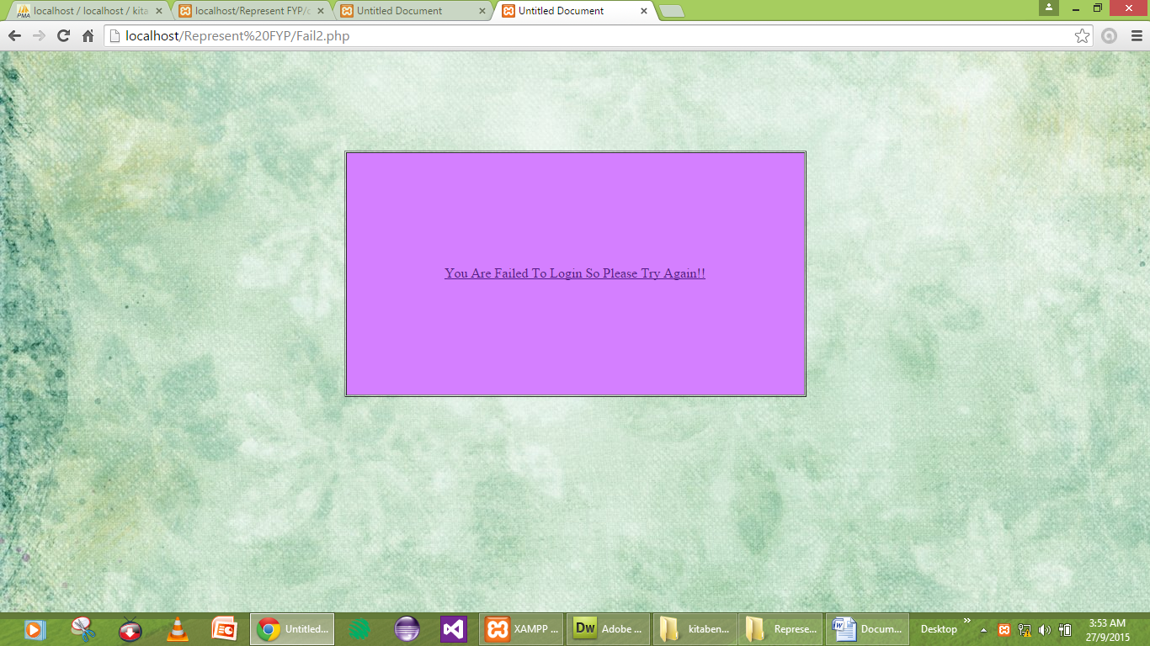

Fail

<!DOCTYPE html PUBLIC "-//W3C//DTD XHTML 1.0 Transitional//EN" "http://www.w3.org/TR/xhtml1/DTD/xhtml1-transitional.dtd">

<html xmlns="http://www.w3.org/1999/xhtml">

<head>

<meta http-equiv="Content-Type" content="text/html; charset=utf-8" />

<title>Untitled Document</title>

<style type="text/css">

<!--

body,td,th {

font-family: Times New Roman, Times, serif;

font-size: 16px;

color: #FF9FAA;

}

body {

background-image: url(14.jpg);

color: #0D0;

}

-->

</style></head>

<body>

<div align="center">

<p>&nbsp;</p>

<p>&nbsp;</p>

<p>&nbsp;</p>

</div>

<div align="center">

<table width="549" height="289" border="1" cellpadding="1" cellspacing="1">

<tr>

<td width="541" height="285" bgcolor="#D47FFF"><div align="center"><a href="Login3.php">You Are Failed To Login So Please Try Again!!</a></div></td>

</tr>

</table>

</div>

</body>

</html>

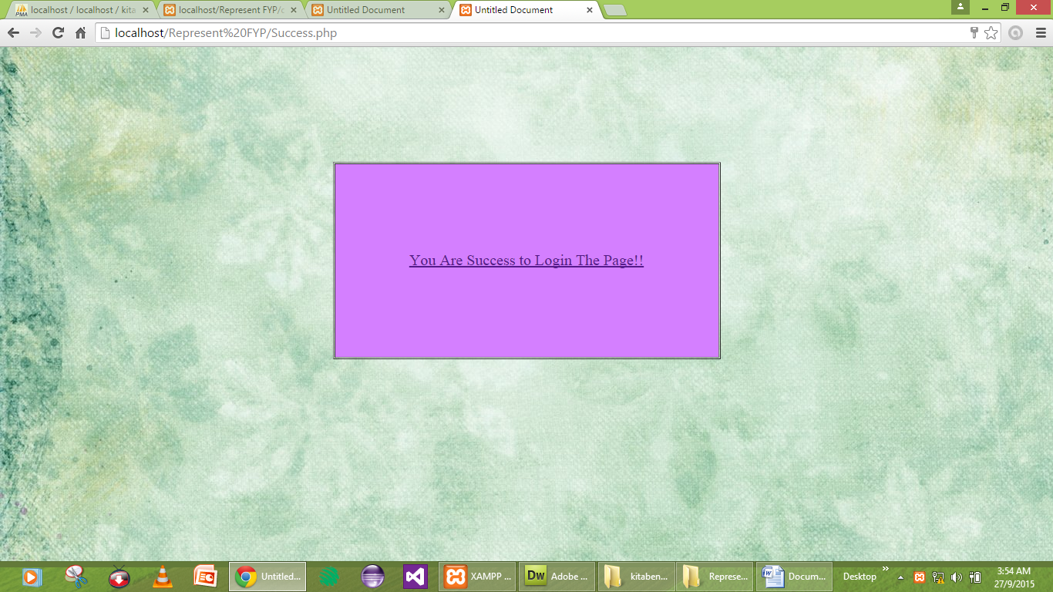

success

<!DOCTYPE html PUBLIC "-//W3C//DTD XHTML 1.0 Transitional//EN" "http://www.w3.org/TR/xhtml1/DTD/xhtml1-transitional.dtd">

<html xmlns="http://www.w3.org/1999/xhtml">

<head>

<meta http-equiv="Content-Type" content="text/html; charset=utf-8" />

<title>Untitled Document</title>

<style type="text/css">

body {

background-color: #FFF;

background-image: url(14.jpg);

}

body,td,th {

font-size: 20px;

color: #000;

text-align: center;

}

</style>

</head>

<body>

<p>&nbsp;</p>

<p>&nbsp;</p>

<p>&nbsp;</p>

<table width="503" height="256" border="1" align="center" cellpadding="1" cellspacing="1">

<tr>

<td width="495" bgcolor="#D47FFF"><div align="center"><a href="Home.php"> You Are Success to Login The Page!!</a> <a href="Home.php"></a></div></td>

</tr>

</table>

<p>&nbsp;</p>

<p><a href="Home.php"></a></p>

</body>

</html>

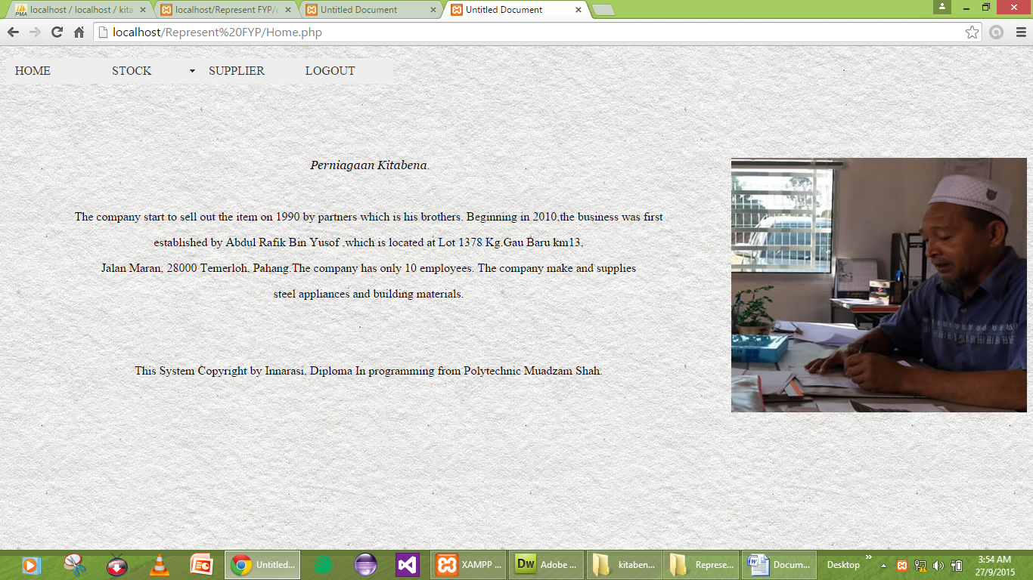

Home

<?php

//initialize the session

if (!isset($_SESSION)) {

session_start();

}

// ** Logout the current user. **

$logoutAction = $_SERVER['PHP_SELF']."?doLogout=true";

if ((isset($_SERVER['QUERY_STRING'])) && ($_SERVER['QUERY_STRING'] != "")){

$logoutAction .="&". htmlentities($_SERVER['QUERY_STRING']);

}

if ((isset($_GET['doLogout'])) &&($_GET['doLogout']=="true")){

//to fully log out a visitor we need to clear the session varialbles

$_SESSION['MM_Username'] = NULL;

$_SESSION['MM_UserGroup'] = NULL;

$_SESSION['PrevUrl'] = NULL;

unset($_SESSION['MM_Username']);

unset($_SESSION['MM_UserGroup']);

unset($_SESSION['PrevUrl']);

$logoutGoTo = "Welcome page.php";

if ($logoutGoTo) {

header("Location: $logoutGoTo");

exit;

}

}

?>

<!DOCTYPE html PUBLIC "-//W3C//DTD XHTML 1.0 Transitional//EN" "http://www.w3.org/TR/xhtml1/DTD/xhtml1-transitional.dtd">

<html xmlns="http://www.w3.org/1999/xhtml">

<head>

<meta http-equiv="Content-Type" content="text/html; charset=utf-8" />

<title>Untitled Document</title>

<style type="text/css">

#form1 p {

text-align: center;

}

body {

background-color: #F5EEEE;

color: #000;

background-image: url(../images%20(4)

.jpg);

background-repeat: repeat;

background-image: url(003-subtle-light-pattern-background-texture-vol51.jpg);

}

#form2 div a {

color: #000;

}

#form1 div button h3 {

font-weight: bold;

}

#form1 div button h3 {

color: #600;

}

#form1 p button h3 {

color: #600;

}

</style>

<link href="login2.php.css" rel="stylesheet" type="text/css" />

<style type="text/css">

<!--

#apDiv1 {

position:absolute;

width:453px;

height:35px;

z-index:1;

left: 11px;

top: 12px;

}

-->

</style>

<style type="text/css">

<!--

#apDiv2 {

position:absolute;

width:200px;

height:115px;

z-index:1;

}

#form1 table {

font-size: 16px;

}

#form1 table {

font-size: 10px;

}

#form1 table {

font-size: 10cm;

}

#form1 div p {

font-size: 18px;

}

#form1 div p {

font-size: 36px;

}

#form1 div p {

font-family: Verdana, Geneva, sans-serif;

}

#form1 div p {

font-family: MS Serif, New York, serif;

}

#form1 p em {

font-family: Georgia, Times New Roman, Times, serif;

}

#form1 div p {

font-size: 42px;

}

#form1 div p {

font-size: 36px;

}

#form1 div p {

color: #FFF;

}

-->

</style>

<script src="SpryAssets/SpryMenuBar.js" type="text/javascript"></script>

<link href="SpryAssets/SpryMenuBarHorizontal.css" rel="stylesheet" type="text/css" />

</head>

<body>

<ul id="MenuBar1" class="MenuBarHorizontal">

<li><a href="Home.php">HOME</a> </li>

<li><a href="#" class="MenuBarItemSubmenu">STOCK</a>

<ul>

<li><a href="insert.php">INSERT</a></li>

<li><a href="update.php">UPDATE</a></li>

<li><a href="view.php">DELETE</a></li>

</ul>

</li>

<li><a href="Supplier.php">SUPPLIER</a> </li>

<li><a href="Welcome.php">LOGOUT</a></li>

</ul>

<form id="form1" name="form1" method="get" action="Stock2.php">

<div align="center"></div>

</form>

<form id="form1" name="form1" method="get" action="Supplier.php">

<div align="justify"> </div>

<p align="justify">&nbsp;</p>

<div align="left">

<p>&nbsp;</p>

<p><a name="_GoBack" id="_GoBack"></a></p>

<table width="12" border="0" align="right" cellpadding="0" cellspacing="0">

<tr>

<td><img src="untitled.jpg" alt="&lt;img src=&quot;../untitled.jpg&quot; width=&quot;786&quot; height=&quot;444&quot; /&gt;" width="391" height="337" /></td>

</tr>

</table>

</div>

<p align="left"><em>Perniagaan Kitabena </em></p>

<p>&nbsp;</p>

<p>The company start to sell out the item on 1990 by partners which is his brothers. Beginning in 2010,the business was first</p>

<p> established by Abdul Rafik Bin Yusof ,which is located at Lot 1378 Kg.Gau Baru km13, </p>

<p>Jalan Maran, 28000 Temerloh, Pahang.The company has only 10 employees. The company make and supplies </p>

<p>steel appliances and building materials.</p>

<p>&nbsp;</p>

<p>&nbsp;</p>

<p>This System Copyright by Innarasi, Diploma In programming from Polytechnic Muadzam Shah.</p>

<p align="left">&nbsp;</p>

</form>

<p></form>

</p>

<script type="text/javascript">

<!--

var MenuBar1 = new Spry.Widget.MenuBar("MenuBar1", {imgDown:"SpryAssets/SpryMenuBarDownHover.gif", imgRight:"SpryAssets/SpryMenuBarRightHover.gif"});

//-->

</script>

</body>

</html>

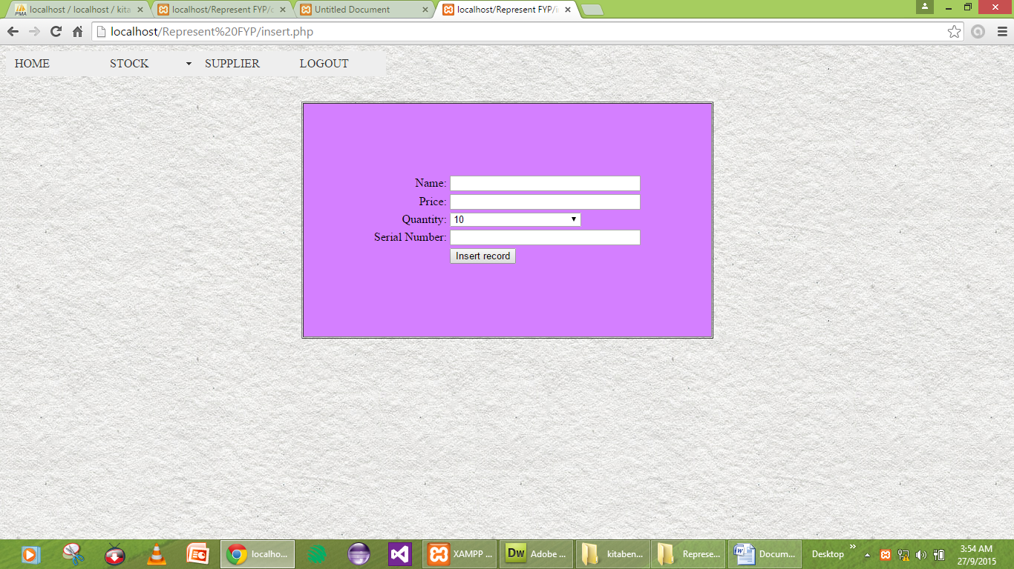

insert

<?php require_once('C:/xampp/htdocs/Kitabena_Project/kitabena project/Connections/Kitabenaconnnection.php'); ?>

<?php

if (!function_exists("GetSQLValueString")) {

function GetSQLValueString($theValue, $theType, $theDefinedValue = "", $theNotDefinedValue = "")

{

if (PHP_VERSION < 6) {

$theValue = get_magic_quotes_gpc() ? stripslashes($theValue) : $theValue;

}

$theValue = function_exists("mysql_real_escape_string") ? mysql_real_escape_string($theValue) : mysql_escape_string($theValue);

switch ($theType) {

case "text":

$theValue = ($theValue != "") ? "'" . $theValue . "'" : "NULL";

break;

case "long":

case "int":

$theValue = ($theValue != "") ? intval($theValue) : "NULL";

break;

case "double":

$theValue = ($theValue != "") ? doubleval($theValue) : "NULL";

break;

case "date":

$theValue = ($theValue != "") ? "'" . $theValue . "'" : "NULL";

break;

case "defined":

$theValue = ($theValue != "") ? $theDefinedValue : $theNotDefinedValue;

break;

}

return $theValue;

}

}

$editFormAction = $_SERVER['PHP_SELF'];

if (isset($_SERVER['QUERY_STRING'])) {

$editFormAction .= "?" . htmlentities($_SERVER['QUERY_STRING']);

}

if ((isset($_POST["MM_insert"])) && ($_POST["MM_insert"] == "form4")) {

$insertSQL = sprintf("INSERT INTO stock (Name, Price, Quantity, `Serial Number`) VALUES (%s, %s, %s, %s)",

GetSQLValueString($_POST['Name'], "text"),

GetSQLValueString($_POST['Price'], "double"),

GetSQLValueString($_POST['Quantity'], "int"),

GetSQLValueString($_POST['Serial_Number'], "text"));

mysql_select_db($database_Kitabenaconnnection, $Kitabenaconnnection);

$Result1 = mysql_query($insertSQL, $Kitabenaconnnection) or die(mysql_error());

$insertGoTo = "view.php";

if (isset($_SERVER['QUERY_STRING'])) {

$insertGoTo .= (strpos($insertGoTo, '?')) ? "&" : "?";

$insertGoTo .= $_SERVER['QUERY_STRING'];

}

header(sprintf("Location: %s", $insertGoTo));

}

mysql_select_db($database_Kitabenaconnnection, $Kitabenaconnnection);

$query_Stock = "SELECT * FROM stock";

$Stock = mysql_query($query_Stock, $Kitabenaconnnection) or die(mysql_error());

$row_Stock = mysql_fetch_assoc($Stock);

$totalRows_Stock = mysql_num_rows($Stock);

?>

<style type="text/css">

<!--

body {

background-image: url(003-subtle-light-pattern-background-texture-vol51.jpg);

background-color: #9F9;

}

-->

</style>

<script src="SpryAssets/SpryMenuBar.js" type="text/javascript"></script>

<link href="SpryAssets/SpryMenuBarHorizontal.css" rel="stylesheet" type="text/css" />

<link href="SpryAssets/SpryMenuBarVertical.css" rel="stylesheet" type="text/css" />

<form id="form3" name="form1" method="get" action="Stock2.php">

<ul id="MenuBar1" class="MenuBarHorizontal">

<li><a href="Home.php">HOME</a></li>

<li><a href="#" class="MenuBarItemSubmenu">STOCK</a>

<ul>

<li><a href="insert.php">INSERT</a></li>

<li><a href="update.php">UPDATE</a></li>

<li><a href="view.php">DELETE</a></li>

</ul>

</li>

<li><a href="Supplier.php">SUPPLIER</a></li>

<li><a href="Welcome.php">LOGOUT</a></li>

</ul>

</form>

<form method="post" name="form3" id="form3">

<p>&nbsp;</p>

<p>&nbsp;</p>

</form>

<form method="post" name="form2" id="form2">

<div align="center">

<table width="555" height="320" border="1" cellpadding="1" cellspacing="1">

<tr bgcolor="#D4BF55">

<td width="372" bgcolor="#D47FFF"><div align="center">

<table align="center">

<tr valign="baseline">

<td nowrap="nowrap" align="right">Name:</td>

<td><input type="text" name="Name" value="" size="32" /></td>

</tr>

<tr valign="baseline">

<td nowrap="nowrap" align="right">Price:</td>

<td><input type="text" name="Price" value="" size="32" /></td>

</tr>

<tr valign="baseline">

<td nowrap="nowrap" align="right">Quantity:</td>

<td><label for="select"></label>

<select name="select" id="select">

<option value="">10</option>

<option value="">20</option>

<option value="">30</option>

<option value="">40</option>

<option value="">50</option>

<option value="">60</option>

<option value="">70</option>

<option value="">80</option>

<option value="">90</option>

<option value="">100</option>

<?php

do {

?>

<option value="<?php echo $row_Stock['Name']?>"><?php echo $row_Stock['Name']?></option>

<?php

} while ($row_Stock = mysql_fetch_assoc($Stock));

$rows = mysql_num_rows($Stock);

if($rows > 0) {

mysql_data_seek($Stock, 0);

$row_Stock = mysql_fetch_assoc($Stock);

}

?>

</select></td>

</tr>

<tr valign="baseline">

<td nowrap="nowrap" align="right">Serial Number:</td>

<td><input type="text" name="Serial_Number" value="" size="32" /></td>

</tr>

<tr valign="baseline">

<td nowrap="nowrap" align="right">&nbsp;</td>

<td><input type="submit" value="Insert record" /></td>

</tr>

</table>

<input type="hidden" name="MM_insert" value="form4" />

</div>

<?php

mysql_free_result($Stock);

?></td>

</tr>

</table>

</div>

</form>

<p>&nbsp;</p>

<p>&nbsp;</p>

<p>&nbsp;</p>

<script type="text/javascript">

<!--

var MenuBar1 = new Spry.Widget.MenuBar("MenuBar1", {imgDown:"SpryAssets/SpryMenuBarDownHover.gif", imgRight:"SpryAssets/SpryMenuBarRightHover.gif"});

//-->

</script>

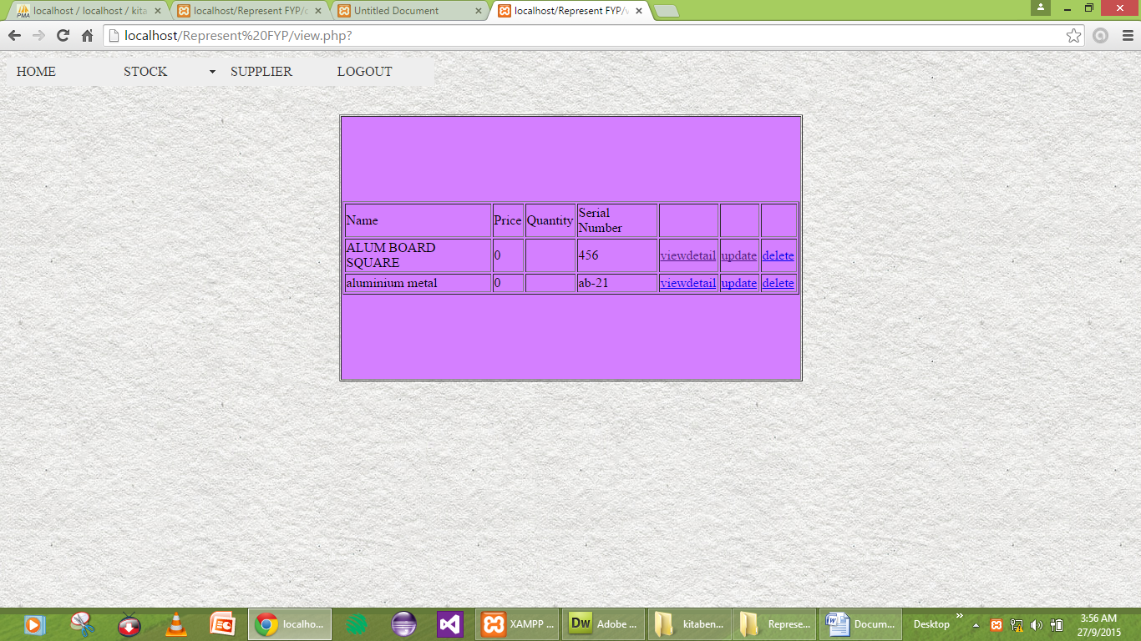

view

<?php require_once('C:/xampp/htdocs/Kitabena_Project/kitabena project/Connections/Kitabenaconnnection.php'); ?>

<?php

if (!function_exists("GetSQLValueString")) {

function GetSQLValueString($theValue, $theType, $theDefinedValue = "", $theNotDefinedValue = "")

{

if (PHP_VERSION < 6) {

$theValue = get_magic_quotes_gpc() ? stripslashes($theValue) : $theValue;

}

$theValue = function_exists("mysql_real_escape_string") ? mysql_real_escape_string($theValue) : mysql_escape_string($theValue);

switch ($theType) {

case "text":

$theValue = ($theValue != "") ? "'" . $theValue . "'" : "NULL";

break;

case "long":

case "int":

$theValue = ($theValue != "") ? intval($theValue) : "NULL";

break;

case "double":

$theValue = ($theValue != "") ? doubleval($theValue) : "NULL";

break;

case "date":

$theValue = ($theValue != "") ? "'" . $theValue . "'" : "NULL";

break;

case "defined":

$theValue = ($theValue != "") ? $theDefinedValue : $theNotDefinedValue;

break;

}

return $theValue;

}

}

$editFormAction = $_SERVER['PHP_SELF'];

if (isset($_SERVER['QUERY_STRING'])) {

$editFormAction .= "?" . htmlentities($_SERVER['QUERY_STRING']);

}

if ((isset($_POST["MM_insert"])) && ($_POST["MM_insert"] == "form4")) {

$insertSQL = sprintf("INSERT INTO stock (Name, Price, Quantity, `Serial Number`) VALUES (%s, %s, %s, %s)",

GetSQLValueString($_POST['Name'], "text"),

GetSQLValueString($_POST['Price'], "double"),

GetSQLValueString($_POST['Quantity'], "int"),

GetSQLValueString($_POST['Serial_Number'], "text"));

mysql_select_db($database_Kitabenaconnnection, $Kitabenaconnnection);

$Result1 = mysql_query($insertSQL, $Kitabenaconnnection) or die(mysql_error());

$insertGoTo = "view.php";

if (isset($_SERVER['QUERY_STRING'])) {

$insertGoTo .= (strpos($insertGoTo, '?')) ? "&" : "?";

$insertGoTo .= $_SERVER['QUERY_STRING'];

}

header(sprintf("Location: %s", $insertGoTo));

}

mysql_select_db($database_Kitabenaconnnection, $Kitabenaconnnection);

$query_Stock = "SELECT * FROM stock";

$Stock = mysql_query($query_Stock, $Kitabenaconnnection) or die(mysql_error());

$row_Stock = mysql_fetch_assoc($Stock);

$totalRows_Stock = mysql_num_rows($Stock);

?>

<style type="text/css">

<!--

body {

background-image: url(003-subtle-light-pattern-background-texture-vol51.jpg);

background-color: #9F9;

}

-->

</style>

<script src="SpryAssets/SpryMenuBar.js" type="text/javascript"></script>

<link href="SpryAssets/SpryMenuBarHorizontal.css" rel="stylesheet" type="text/css" />

<link href="SpryAssets/SpryMenuBarVertical.css" rel="stylesheet" type="text/css" />

<form id="form3" name="form1" method="get" action="Stock2.php">

<ul id="MenuBar1" class="MenuBarHorizontal">

<li><a href="Home.php">HOME</a></li>

<li><a href="#" class="MenuBarItemSubmenu">STOCK</a>

<ul>

<li><a href="insert.php">INSERT</a></li>

<li><a href="update.php">UPDATE</a></li>

<li><a href="view.php">DELETE</a></li>

</ul>

</li>

<li><a href="Supplier.php">SUPPLIER</a></li>

<li><a href="Welcome.php">LOGOUT</a></li>

</ul>

</form>

<form method="post" name="form3" id="form3">

<p>&nbsp;</p>

<p>&nbsp;</p>

</form>

<form method="post" name="form2" id="form2">

<div align="center">

<table width="555" height="320" border="1" cellpadding="1" cellspacing="1">

<tr bgcolor="#D4BF55">

<td width="372" bgcolor="#D47FFF"><div align="center">

<table border="1">

<tr>

<td>Name</td>

<td>Price</td>

<td>Quantity</td>

<td>Serial Number</td>

<td>&nbsp;</td>

<td>&nbsp;</td>

<td>&nbsp;</td>

</tr>

<?php do { ?>

<tr>

<td><?php echo $row_Stock['Name']; ?></td>

<td><?php echo $row_Stock['Price']; ?></td>

<td><?php echo $row_Stock['Quantity']; ?></td>

<td><?php echo $row_Stock['Serial Number']; ?></td>

<td><a href="viewdetail.php?Name=<?php echo $row_Stock['Name']; ?>">viewdetail</a></td>

<td><a href="update.php?Name=<?php echo $row_Stock['Name']; ?>">update</a></td>

<td><a href="delete.php?Name=<?php echo $row_Stock['Name']; ?>"onClick="return confirm('Are Sure want To Delete?')">delete</a></td>

</tr>

<?php } while ($row_Stock = mysql_fetch_assoc($Stock)); ?>

</table>

<input type="hidden" name="MM_insert" value="form4" />

</div>

<?php

mysql_free_result($Stock);

?></td>

</tr>

</table>

</div>

</form>

<p>&nbsp;</p>

<p>&nbsp;</p>

<p>&nbsp;</p>

<script type="text/javascript">

<!--

var MenuBar1 = new Spry.Widget.MenuBar("MenuBar1", {imgDown:"SpryAssets/SpryMenuBarDownHover.gif", imgRight:"SpryAssets/SpryMenuBarRightHover.gif"});

//-->

</script>

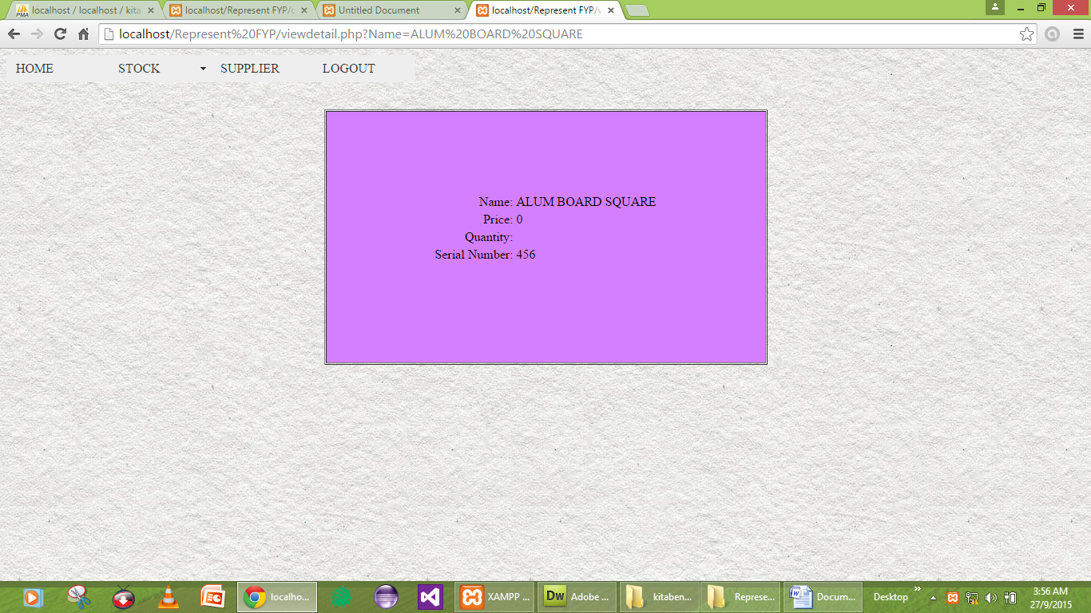

viewdetail

<?php require_once('C:/xampp/htdocs/Kitabena_Project/kitabena project/Connections/Kitabenaconnnection.php'); ?>

<?php

if (!function_exists("GetSQLValueString")) {

function GetSQLValueString($theValue, $theType, $theDefinedValue = "", $theNotDefinedValue = "")

{

if (PHP_VERSION < 6) {

$theValue = get_magic_quotes_gpc() ? stripslashes($theValue) : $theValue;

}

$theValue = function_exists("mysql_real_escape_string") ? mysql_real_escape_string($theValue) : mysql_escape_string($theValue);

switch ($theType) {

case "text":

$theValue = ($theValue != "") ? "'" . $theValue . "'" : "NULL";

break;

case "long":

case "int":

$theValue = ($theValue != "") ? intval($theValue) : "NULL";

break;

case "double":

$theValue = ($theValue != "") ? doubleval($theValue) : "NULL";

break;

case "date":

$theValue = ($theValue != "") ? "'" . $theValue . "'" : "NULL";

break;

case "defined":

$theValue = ($theValue != "") ? $theDefinedValue : $theNotDefinedValue;

break;

}

return $theValue;

}

}

$editFormAction = $_SERVER['PHP_SELF'];

if (isset($_SERVER['QUERY_STRING'])) {

$editFormAction .= "?" . htmlentities($_SERVER['QUERY_STRING']);

}

if ((isset($_POST["MM_insert"])) && ($_POST["MM_insert"] == "form4")) {

$insertSQL = sprintf("INSERT INTO stock (Name, Price, Quantity, `Serial Number`) VALUES (%s, %s, %s, %s)",

GetSQLValueString($_POST['Name'], "text"),

GetSQLValueString($_POST['Price'], "double"),

GetSQLValueString($_POST['Quantity'], "int"),

GetSQLValueString($_POST['Serial_Number'], "text"));

mysql_select_db($database_Kitabenaconnnection, $Kitabenaconnnection);

$Result1 = mysql_query($insertSQL, $Kitabenaconnnection) or die(mysql_error());

$insertGoTo = "view.php";

if (isset($_SERVER['QUERY_STRING'])) {

$insertGoTo .= (strpos($insertGoTo, '?')) ? "&" : "?";

$insertGoTo .= $_SERVER['QUERY_STRING'];

}

header(sprintf("Location: %s", $insertGoTo));

}

if ((isset($_POST["MM_update"])) && ($_POST["MM_update"] == "form4")) {

$updateSQL = sprintf("UPDATE stock SET Price=%s, Quantity=%s, `Serial Number`=%s WHERE Name=%s",

GetSQLValueString($_POST['Price'], "double"),

GetSQLValueString($_POST['Quantity'], "int"),

GetSQLValueString($_POST['Serial_Number'], "text"),

GetSQLValueString($_POST['Name'], "text"));

mysql_select_db($database_Kitabenaconnnection, $Kitabenaconnnection);

$Result1 = mysql_query($updateSQL, $Kitabenaconnnection) or die(mysql_error());

}

mysql_select_db($database_Kitabenaconnnection, $Kitabenaconnnection);

$query_Stock = "SELECT * FROM stock";

$Stock = mysql_query($query_Stock, $Kitabenaconnnection) or die(mysql_error());

$row_Stock = mysql_fetch_assoc($Stock);

$totalRows_Stock = mysql_num_rows($Stock);mysql_select_db($database_Kitabenaconnnection, $Kitabenaconnnection);

$query_Stock = "SELECT * FROM stock";

$Stock = mysql_query($query_Stock, $Kitabenaconnnection) or die(mysql_error());

$row_Stock = mysql_fetch_assoc($Stock);

$totalRows_Stock = mysql_num_rows($Stock);

?>

<style type="text/css">

<!--

body {

background-image: url(003-subtle-light-pattern-background-texture-vol51.jpg);

background-color: #9F9;

}

-->

</style>

<script src="SpryAssets/SpryMenuBar.js" type="text/javascript"></script>

<link href="SpryAssets/SpryMenuBarHorizontal.css" rel="stylesheet" type="text/css" />

<link href="SpryAssets/SpryMenuBarVertical.css" rel="stylesheet" type="text/css" />

<form id="form3" name="form1" method="get" action="Stock2.php">

<ul id="MenuBar1" class="MenuBarHorizontal">

<li><a href="Home.php">HOME</a></li>

<li><a href="#" class="MenuBarItemSubmenu">STOCK</a>

<ul>

<li><a href="insert.php">INSERT</a></li>

<li><a href="update.php">UPDATE</a></li>

<li><a href="view.php">DELETE</a></li>

</ul>

</li>

<li><a href="Supplier.php">SUPPLIER</a></li>

<li><a href="Welcome.php">LOGOUT</a></li>

</ul>

</form>

<form method="post" name="form3" id="form3">

<p>&nbsp;</p>

<p>&nbsp;</p>

</form>

<form method="post" name="form2" id="form2">

<div align="center">

<table width="555" height="320" border="1" cellpadding="1" cellspacing="1">

<tr bgcolor="#D4BF55">

<td width="372" bgcolor="#D47FFF"><?php

mysql_free_result($Stock);

?>

<input type="hidden" name="Name" value="<?php echo $row_Stock['Name']; ?>" />

<input type="hidden" name="MM_update" value="form4" />

<input type="hidden" name="MM_insert" value="form4" />

<table align="center">

<tr valign="baseline">

<td nowrap="nowrap" align="right">Name:</td>

<td><?php echo $row_Stock['Name']; ?></td>

</tr>

<tr valign="baseline">

<td nowrap="nowrap" align="right">Price:</td>

<td><?php echo $row_Stock['Price']; ?></td>

</tr>

<tr valign="baseline">

<td nowrap="nowrap" align="right">Quantity:</td>

<td><?php echo $row_Stock['Quantity']; ?></td>

</tr>

<tr valign="baseline">

<td nowrap="nowrap" align="right">Serial Number:</td>

<td><?php echo $row_Stock['Serial Number']; ?></td>

</tr>

<tr valign="baseline">

<td nowrap="nowrap" align="right">&nbsp;</td>

<td>&nbsp;</td>

</tr>

</table></td>

</tr>

</table>

</div>

</form>

<p>&nbsp;</p>

<p>&nbsp;</p>

<p>&nbsp;</p>

<p>&nbsp;</p>

<script type="text/javascript">

<!--

var MenuBar1 = new Spry.Widget.MenuBar("MenuBar1", {imgDown:"SpryAssets/SpryMenuBarDownHover.gif", imgRight:"SpryAssets/SpryMenuBarRightHover.gif"});

//-->

</script>

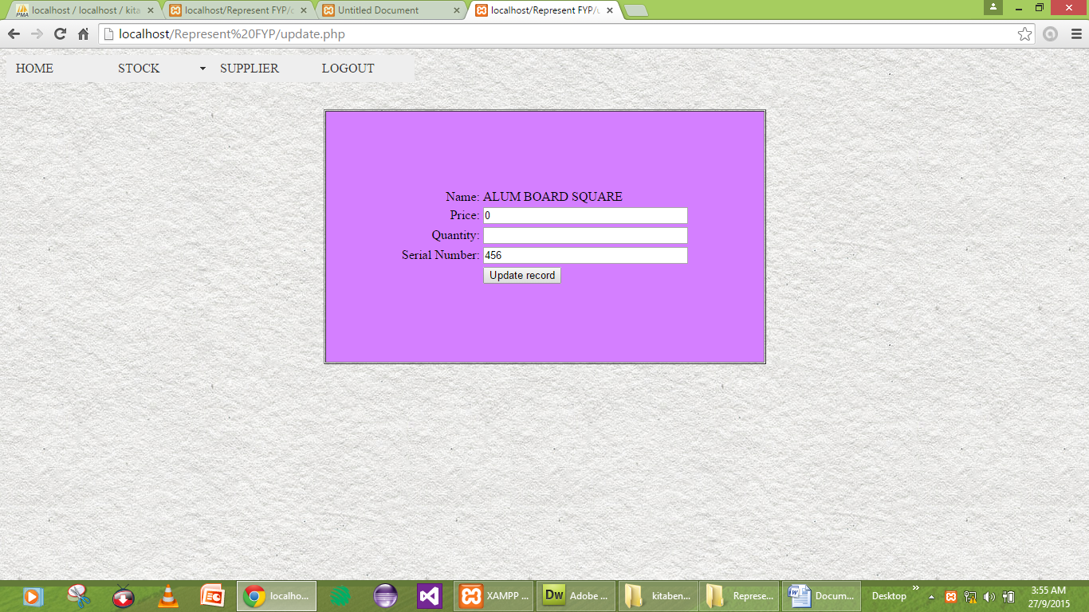

update

<?php require_once('C:/xampp/htdocs/Kitabena_Project/kitabena project/Connections/Kitabenaconnnection.php'); ?>

<?php

if (!function_exists("GetSQLValueString")) {

function GetSQLValueString($theValue, $theType, $theDefinedValue = "", $theNotDefinedValue = "")

{

if (PHP_VERSION < 6) {

$theValue = get_magic_quotes_gpc() ? stripslashes($theValue) : $theValue;

}

$theValue = function_exists("mysql_real_escape_string") ? mysql_real_escape_string($theValue) : mysql_escape_string($theValue);

switch ($theType) {

case "text":

$theValue = ($theValue != "") ? "'" . $theValue . "'" : "NULL";

break;

case "long":

case "int":

$theValue = ($theValue != "") ? intval($theValue) : "NULL";

break;

case "double":

$theValue = ($theValue != "") ? doubleval($theValue) : "NULL";

break;

case "date":

$theValue = ($theValue != "") ? "'" . $theValue . "'" : "NULL";

break;

case "defined":

$theValue = ($theValue != "") ? $theDefinedValue : $theNotDefinedValue;

break;

}

return $theValue;

}

}

$editFormAction = $_SERVER['PHP_SELF'];

if (isset($_SERVER['QUERY_STRING'])) {

$editFormAction .= "?" . htmlentities($_SERVER['QUERY_STRING']);

}

if ((isset($_POST["MM_insert"])) && ($_POST["MM_insert"] == "form4")) {

$insertSQL = sprintf("INSERT INTO stock (Name, Price, Quantity, `Serial Number`) VALUES (%s, %s, %s, %s)",

GetSQLValueString($_POST['Name'], "text"),

GetSQLValueString($_POST['Price'], "double"),

GetSQLValueString($_POST['Quantity'], "int"),

GetSQLValueString($_POST['Serial_Number'], "text"));

mysql_select_db($database_Kitabenaconnnection, $Kitabenaconnnection);

$Result1 = mysql_query($insertSQL, $Kitabenaconnnection) or die(mysql_error());

$insertGoTo = "view.php";

if (isset($_SERVER['QUERY_STRING'])) {

$insertGoTo .= (strpos($insertGoTo, '?')) ? "&" : "?";

$insertGoTo .= $_SERVER['QUERY_STRING'];

}

header(sprintf("Location: %s", $insertGoTo));

}

if ((isset($_POST["MM_update"])) && ($_POST["MM_update"] == "form4")) {

$updateSQL = sprintf("UPDATE stock SET Price=%s, Quantity=%s, `Serial Number`=%s WHERE Name=%s",

GetSQLValueString($_POST['Price'], "double"),

GetSQLValueString($_POST['Quantity'], "int"),

GetSQLValueString($_POST['Serial_Number'], "text"),

GetSQLValueString($_POST['Name'], "text"));

mysql_select_db($database_Kitabenaconnnection, $Kitabenaconnnection);

$Result1 = mysql_query($updateSQL, $Kitabenaconnnection) or die(mysql_error());

$updateGoTo = "view.php";

if (isset($_SERVER['QUERY_STRING'])) {

$updateGoTo .= (strpos($updateGoTo, '?')) ? "&" : "?";

$updateGoTo .= $_SERVER['QUERY_STRING'];

}

header(sprintf("Location: %s", $updateGoTo));

}

mysql_select_db($database_Kitabenaconnnection, $Kitabenaconnnection);

$query_Stock = "SELECT * FROM stock";

$Stock = mysql_query($query_Stock, $Kitabenaconnnection) or die(mysql_error());

$row_Stock = mysql_fetch_assoc($Stock);

$totalRows_Stock = mysql_num_rows($Stock);

?>

<style type="text/css">

<!--

body {

background-image: url(003-subtle-light-pattern-background-texture-vol51.jpg);

background-color: #9F9;

}

-->

</style>

<script src="SpryAssets/SpryMenuBar.js" type="text/javascript"></script>

<link href="SpryAssets/SpryMenuBarHorizontal.css" rel="stylesheet" type="text/css" />

<link href="SpryAssets/SpryMenuBarVertical.css" rel="stylesheet" type="text/css" />

<form id="form3" name="form1" method="get" action="Stock2.php">

<ul id="MenuBar1" class="MenuBarHorizontal">

<li><a href="Home.php">HOME</a></li>

<li><a href="#" class="MenuBarItemSubmenu">STOCK</a>

<ul>

<li><a href="insert.php">INSERT</a></li>

<li><a href="update.php">UPDATE</a></li>

<li><a href="view.php">DELETE</a></li>

</ul>

</li>

<li><a href="Supplier.php">SUPPLIER</a></li>

<li><a href="Welcome.php">LOGOUT</a></li>

</ul>

</form>

<form method="post" name="form3" id="form3">

<p>&nbsp;</p>

<p>&nbsp;</p>

</form>

<form method="post" name="form2" id="form2">

<div align="center">

<table width="555" height="320" border="1" cellpadding="1" cellspacing="1">

<tr bgcolor="#D4BF55">

<td width="372" bgcolor="#D47FFF"><div align="center">

<input type="hidden" name="MM_insert" value="form4" />

</div>

<?php

mysql_free_result($Stock);

?>

<table align="center">

<tr valign="baseline">

<td nowrap="nowrap" align="right">Name:</td>

<td><?php echo $row_Stock['Name']; ?></td>

</tr>

<tr valign="baseline">

<td nowrap="nowrap" align="right">Price:</td>

<td><input type="text" name="Price" value="<?php echo htmlentities($row_Stock['Price'], ENT_COMPAT, ''); ?>" size="32" /></td>

</tr>

<tr valign="baseline">

<td nowrap="nowrap" align="right">Quantity:</td>

<td><input type="text" name="Quantity" value="<?php echo htmlentities($row_Stock['Quantity'], ENT_COMPAT, ''); ?>" size="32" /></td>

</tr>

<tr valign="baseline">

<td nowrap="nowrap" align="right">Serial Number:</td>

<td><input type="text" name="Serial_Number" value="<?php echo htmlentities($row_Stock['Serial Number'], ENT_COMPAT, ''); ?>" size="32" /></td>

</tr>

<tr valign="baseline">

<td nowrap="nowrap" align="right">&nbsp;</td>

<td><input type="submit" value="Update record" /></td>

</tr>

</table>

<input type="hidden" name="Name" value="<?php echo $row_Stock['Name']; ?>" />

<input type="hidden" name="MM_update" value="form4" /></td>

</tr>

</table>

</div>

</form>

<p>&nbsp;</p>

<p>&nbsp;</p>

<p>&nbsp;</p>

<p>&nbsp;</p>

<script type="text/javascript">

<!--

var MenuBar1 = new Spry.Widget.MenuBar("MenuBar1", {imgDown:"SpryAssets/SpryMenuBarDownHover.gif", imgRight:"SpryAssets/SpryMenuBarRightHover.gif"});

//-->

</script>

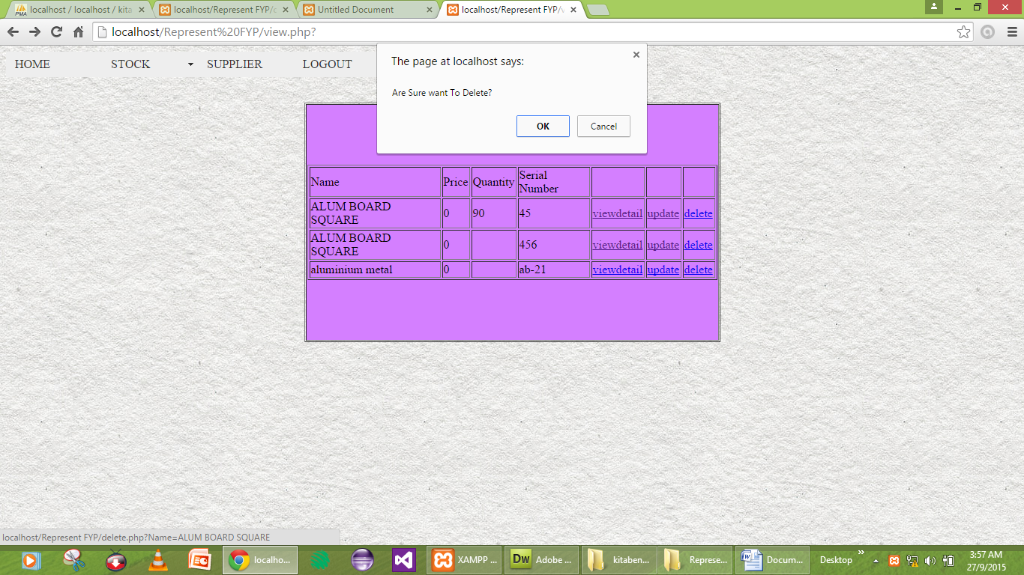

delete

<?php require_once('C:/xampp/htdocs/Kitabena_Project/kitabena project/Connections/Kitabenaconnnection.php'); ?>

<?php

if (!function_exists("GetSQLValueString")) {

function GetSQLValueString($theValue, $theType, $theDefinedValue = "", $theNotDefinedValue = "")

{

if (PHP_VERSION < 6) {

$theValue = get_magic_quotes_gpc() ? stripslashes($theValue) : $theValue;

}

$theValue = function_exists("mysql_real_escape_string") ? mysql_real_escape_string($theValue) : mysql_escape_string($theValue);

switch ($theType) {

case "text":

$theValue = ($theValue != "") ? "'" . $theValue . "'" : "NULL";

break;

case "long":

case "int":

$theValue = ($theValue != "") ? intval($theValue) : "NULL";

break;

case "double":

$theValue = ($theValue != "") ? doubleval($theValue) : "NULL";

break;

case "date":

$theValue = ($theValue != "") ? "'" . $theValue . "'" : "NULL";

break;

case "defined":

$theValue = ($theValue != "") ? $theDefinedValue : $theNotDefinedValue;

break;

}

return $theValue;

}

}

$editFormAction = $_SERVER['PHP_SELF'];

if (isset($_SERVER['QUERY_STRING'])) {

$editFormAction .= "?" . htmlentities($_SERVER['QUERY_STRING']);

}

if ((isset($_POST["MM_insert"])) && ($_POST["MM_insert"] == "form4")) {

$insertSQL = sprintf("INSERT INTO stock (Name, Price, Quantity, `Serial Number`) VALUES (%s, %s, %s, %s)",

GetSQLValueString($_POST['Name'], "text"),

GetSQLValueString($_POST['Price'], "double"),

GetSQLValueString($_POST['Quantity'], "int"),

GetSQLValueString($_POST['Serial_Number'], "text"));

mysql_select_db($database_Kitabenaconnnection, $Kitabenaconnnection);

$Result1 = mysql_query($insertSQL, $Kitabenaconnnection) or die(mysql_error());

$insertGoTo = "view.php";

if (isset($_SERVER['QUERY_STRING'])) {

$insertGoTo .= (strpos($insertGoTo, '?')) ? "&" : "?";

$insertGoTo .= $_SERVER['QUERY_STRING'];

}

header(sprintf("Location: %s", $insertGoTo));

}

if ((isset($_POST["MM_update"])) && ($_POST["MM_update"] == "form4")) {

$updateSQL = sprintf("UPDATE stock SET Price=%s, Quantity=%s, `Serial Number`=%s WHERE Name=%s",

GetSQLValueString($_POST['Price'], "double"),

GetSQLValueString($_POST['Quantity'], "int"),

GetSQLValueString($_POST['Serial_Number'], "text"),

GetSQLValueString($_POST['Name'], "text"));

mysql_select_db($database_Kitabenaconnnection, $Kitabenaconnnection);

$Result1 = mysql_query($updateSQL, $Kitabenaconnnection) or die(mysql_error());

$updateGoTo = "view.php";

if (isset($_SERVER['QUERY_STRING'])) {

$updateGoTo .= (strpos($updateGoTo, '?')) ? "&" : "?";

$updateGoTo .= $_SERVER['QUERY_STRING'];

}

header(sprintf("Location: %s", $updateGoTo));

}

if ((isset($_GET['Name'])) && ($_GET['Name'] != "")) {

$deleteSQL = sprintf("DELETE FROM stock WHERE Name=%s",

GetSQLValueString($_GET['Name'], "text"));

mysql_select_db($database_Kitabenaconnnection, $Kitabenaconnnection);

$Result1 = mysql_query($deleteSQL, $Kitabenaconnnection) or die(mysql_error());

$deleteGoTo = "view.php";

if (isset($_SERVER['QUERY_STRING'])) {

$deleteGoTo .= (strpos($deleteGoTo, '?')) ? "&" : "?";

$deleteGoTo .= $_SERVER['QUERY_STRING'];

}

header(sprintf("Location: %s", $deleteGoTo));

}

mysql_select_db($database_Kitabenaconnnection, $Kitabenaconnnection);

$query_Stock = "SELECT * FROM stock";

$Stock = mysql_query($query_Stock, $Kitabenaconnnection) or die(mysql_error());

$row_Stock = mysql_fetch_assoc($Stock);

$totalRows_Stock = mysql_num_rows($Stock);

?>

<style type="text/css">

<!--

body {

background-image: url(003-subtle-light-pattern-background-texture-vol51.jpg);

background-color: #9F9;

}

-->

</style>

<script src="SpryAssets/SpryMenuBar.js" type="text/javascript"></script>

<link href="SpryAssets/SpryMenuBarHorizontal.css" rel="stylesheet" type="text/css" />

<link href="SpryAssets/SpryMenuBarVertical.css" rel="stylesheet" type="text/css" />

<form id="form3" name="form1" method="get" action="Stock2.php">

<ul id="MenuBar1" class="MenuBarHorizontal">

<li><a href="Home.php">HOME</a></li>

<li><a href="#" class="MenuBarItemSubmenu">STOCK</a>

<ul>

<li><a href="insert.php">INSERT</a></li>

<li><a href="update.php">UPDATE</a></li>

<li><a href="view.php">DELETE</a></li>

</ul>

</li>

<li><a href="Supplier.php">SUPPLIER</a></li>

<li><a href="Welcome.php">LOGOUT</a></li>

</ul>

</form>

<form method="post" name="form3" id="form3">

<p>&nbsp;</p>

<p>&nbsp;</p>

</form>

<form method="post" name="form2" id="form2">

<div align="center">

<table width="555" height="320" border="1" cellpadding="1" cellspacing="1">

<tr bgcolor="#D4BF55">

<td width="372" bgcolor="#D47FFF"><div align="center">

<input type="hidden" name="MM_insert" value="form4" />

</div>

<?php

mysql_free_result($Stock);

?>

<input type="hidden" name="Name" value="<?php echo $row_Stock['Name']; ?>" />

<input type="hidden" name="MM_update" value="form4" /></td>

</tr>

</table>

</div>

</form>

<p>&nbsp;</p>

<p>&nbsp;</p>

<p>&nbsp;</p>

<p>&nbsp;</p>

<script type="text/javascript">

<!--

var MenuBar1 = new Spry.Widget.MenuBar("MenuBar1", {imgDown:"SpryAssets/SpryMenuBarDownHover.gif", imgRight:"SpryAssets/SpryMenuBarRightHover.gif"});

//-->

</script>

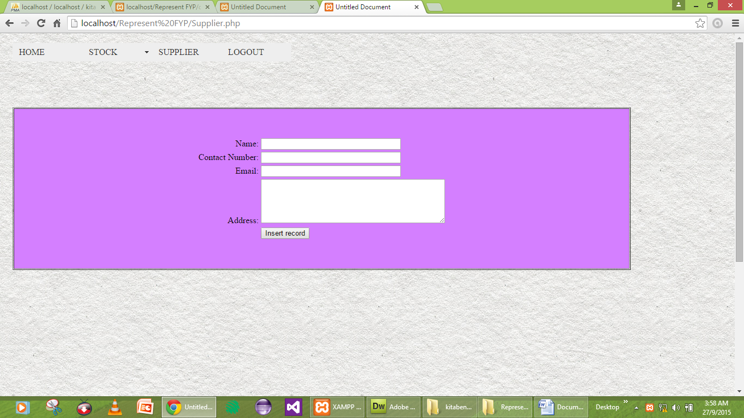

supplier

<?php require_once('Connections/Kitabenaconnnection.php'); ?>

<?php

if (!function_exists("GetSQLValueString")) {

function GetSQLValueString($theValue, $theType, $theDefinedValue = "", $theNotDefinedValue = "")

{

if (PHP_VERSION < 6) {

$theValue = get_magic_quotes_gpc() ? stripslashes($theValue) : $theValue;

}

$theValue = function_exists("mysql_real_escape_string") ? mysql_real_escape_string($theValue) : mysql_escape_string($theValue);

switch ($theType) {

case "text":

$theValue = ($theValue != "") ? "'" . $theValue . "'" : "NULL";

break;

case "long":

case "int":

$theValue = ($theValue != "") ? intval($theValue) : "NULL";

break;

case "double":

$theValue = ($theValue != "") ? doubleval($theValue) : "NULL";

break;

case "date":

$theValue = ($theValue != "") ? "'" . $theValue . "'" : "NULL";

break;

case "defined":

$theValue = ($theValue != "") ? $theDefinedValue : $theNotDefinedValue;

break;

}

return $theValue;

}

}

$editFormAction = $_SERVER['PHP_SELF'];

if (isset($_SERVER['QUERY_STRING'])) {

$editFormAction .= "?" . htmlentities($_SERVER['QUERY_STRING']);

}

if ((isset($_POST["MM_insert"])) && ($_POST["MM_insert"] == "form2")) {

$insertSQL = sprintf("INSERT INTO supplier (name, `Contact Number`, email, address) VALUES (%s, %s, %s, %s)",

GetSQLValueString($_POST['name'], "text"),

GetSQLValueString($_POST['Contact_Number'], "int"),

GetSQLValueString($_POST['email'], "text"),

GetSQLValueString($_POST['address'], "text"));

mysql_select_db($database_Kitabenaconnnection, $Kitabenaconnnection);

$Result1 = mysql_query($insertSQL, $Kitabenaconnnection) or die(mysql_error());

$insertGoTo = "SupplierUpdate.php";

if (isset($_SERVER['QUERY_STRING'])) {

$insertGoTo .= (strpos($insertGoTo, '?')) ? "&" : "?";

$insertGoTo .= $_SERVER['QUERY_STRING'];

}

header(sprintf("Location: %s", $insertGoTo));

}

mysql_select_db($database_Kitabenaconnnection, $Kitabenaconnnection);

$query_Supplier = "SELECT * FROM supplier";

$Supplier = mysql_query($query_Supplier, $Kitabenaconnnection) or die(mysql_error());

$row_Supplier = mysql_fetch_assoc($Supplier);

$totalRows_Supplier = mysql_num_rows($Supplier);

$query_Supplier = "SELECT * FROM supplier";

$Supplier = mysql_query($query_Supplier, $Kitabenaconnnection) or die(mysql_error());

$row_Supplier = mysql_fetch_assoc($Supplier);

$totalRows_Supplier = mysql_num_rows($Supplier);

?>

<!DOCTYPE html PUBLIC "-//W3C//DTD XHTML 1.0 Transitional//EN" "http://www.w3.org/TR/xhtml1/DTD/xhtml1-transitional.dtd">

<html xmlns="http://www.w3.org/1999/xhtml">

<head>

<meta http-equiv="Content-Type" content="text/html; charset=utf-8" />

<title>Untitled Document</title>

<style type="text/css">

@import url("Home.php.css");

#form1 {

text-align: left;

}

#form1 p {

text-align: center;

}

#form1 p label {

text-align: left;

}

#form1 p label {

text-align: left;

}

#form1 p label {

text-align: left;

}

#form1 p {

text-align: left;

}

body {

background-color: #FFF;

background-image: url(../images%20(4)

.jpg);

background-image: url(Inna/Background/background-pattern-design-56%20(1)

.jpg);

background-image: url(Inna/Background/images%20(9)

.jpg);

background-image: url(003-subtle-light-pattern-background-texture-vol51.jpg);

}

#form1 p label {

text-align: left;

}

#form1 div p label {

text-align: justify;

}

#form1 div p label {

text-align: left;

}

#form1 div p label {

text-align: left;

}

#form1 div p label {

text-align: left;

}

#form1 div p label {

text-align: justify;

}

#form1 div p label {

text-align: left;

}

#form1 div button strong {

color: #009;

}

#MenuBar {

color: #FF80C0;

}

ul {

color: #80FF00;

}

</style>

<link href="Home.php.css" rel="stylesheet" type="text/css" />

<link href="includes/ice/Level1_Arial.css" rel="stylesheet" type="text/css" media="all" />

<link href="../CSS/Level1_Arial.css" rel="stylesheet" type="text/css" />

<style type="text/css">

<!--

a:link {

color: #0FF;

}

#MenuBar {

color: #FF8080;

}

#MenuBar li {

color: #FF8040;

}

#MenuBar li {

color: #FF0;

}

-->

</style>

<script src="SpryAssets/SpryMenuBar.js" type="text/javascript"></script>

<link href="SpryAssets/SpryMenuBarHorizontal.css" rel="stylesheet" type="text/css" />

<link href="SpryAssets/SpryMenuBarVertical.css" rel="stylesheet" type="text/css" />

</head>

<body>

<p><label></label>

<form id="form1" name="form1" method="get" action="Supplier.php">

<div align="center"></div>

</form>

<tr>

<td width="378"><table width="1237" border="0" cellspacing="1" cellpadding="1">

<tr>

<td width="10" height="738"><p>&nbsp;</p>

<p>&nbsp;</p>

<p>&nbsp;</p>

<p>&nbsp;</p>

<p>&nbsp;</p>

<legend></legend>

<legend></legend>

<legend></legend>

<p>&nbsp;</p>

<p>

<legend></legend>

</p>

<p>&nbsp;</p>

<p>&nbsp;</p>

<p>&nbsp;</p>

<p>&nbsp;</p>

<form method="post" name="form4" id="form4">

</form>

<p>&nbsp;</p>

<p>&nbsp;</p>

<p>&nbsp;</p>

<p>&nbsp;</p> <legend></legend></td>

<td width="1220"><ul id="MenuBar1" class="MenuBarHorizontal">

<li><a href="Home.php">HOME</a></li>

<li><a href="#" class="MenuBarItemSubmenu">STOCK</a>

<ul>

<li><a href="insert.php">INSERT</a></li>

<li><a href="update.php">UPDATE</a></li>

<li><a href="view.php">DELETE</a></li>

</ul>

</li>

<li><a href="Supplier.php">SUPPLIER</a></li>

<li><a href="Welcome.php">LOGOUT</a></li>

</ul>

<p>&nbsp;</p>

<p>&nbsp;</p>

<p>&nbsp;</p>

<table width="1135" border="1" cellspacing="1" cellpadding="1">

<tr>

<td width="1127" bgcolor="#D47FFF"><p>&nbsp;</p>

<form action="<?php echo $editFormAction; ?>" method="post" enctype="multipart/form-data" name="form2" id="form2">

<table align="center">

<tr valign="baseline">

<td nowrap="nowrap" align="right">Name:</td>

<td><input type="text" name="name" value="" size="32" /></td>

</tr>

<tr valign="baseline">

<td nowrap="nowrap" align="right">Contact Number:</td>

<td><input type="text" name="Contact_Number" value="" size="32" /></td>

</tr>

<tr valign="baseline">

<td nowrap="nowrap" align="right">Email:</td>

<td><input type="text" name="email" value="" size="32" /></td>

</tr>

<tr valign="baseline">

<td nowrap="nowrap" align="right">Address:</td>

<td><label for="textarea"></label>

<textarea name="textarea" id="textarea" cols="45" rows="5"></textarea></td>

</tr>

<tr valign="baseline">

<td nowrap="nowrap" align="right">&nbsp;</td>

<td><input type="submit" value="Insert record" /></td>

</tr>

</table>

<input type="hidden" name="MM_insert" value="form2" />

</form>

<p>&nbsp;</p></td>

</tr>

</table>

<p>&nbsp;</p>

<p>&nbsp;</p>

<p>&nbsp;</p>

<p>&nbsp;</p>

<p>&nbsp;</p>

<p>&nbsp;</p>

<p>&nbsp;</p>

<p>&nbsp;</p>

<p>&nbsp;</p>

<p>&nbsp;</p>

<p>&nbsp;</p>

<p>&nbsp;</p>

<p>&nbsp;</p>

<p>&nbsp; </p></td>

</tr>

</table>

<div align="center"></div>

<p>&nbsp;</p>

<p>&nbsp;</p>

<form method="post" name="form3" id="form3">

</form>

<p>&nbsp;</p>

<script type="text/javascript">

<!--

var MenuBar1 = new Spry.Widget.MenuBar("MenuBar1", {imgDown:"SpryAssets/SpryMenuBarDownHover.gif", imgRight:"SpryAssets/SpryMenuBarRightHover.gif"});

//-->

</script>

</body>

</html>

<?php

mysql_free_result($Supplier);

?>

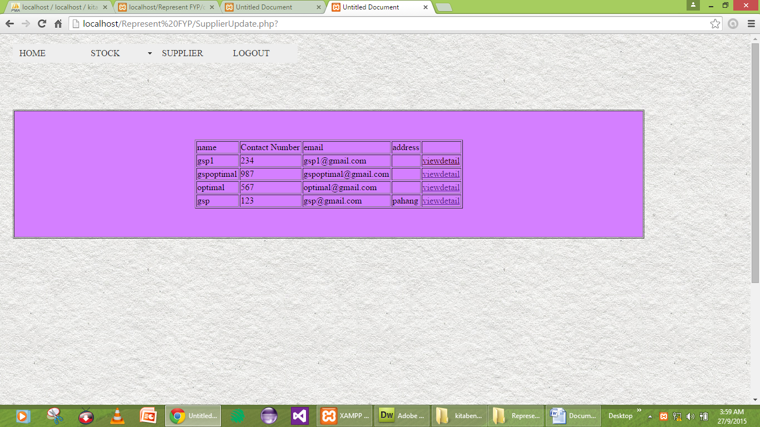

Supplierupdate

<?php require_once('Connections/Kitabenaconnnection.php'); ?>

<?php

if (!function_exists("GetSQLValueString")) {

function GetSQLValueString($theValue, $theType, $theDefinedValue = "", $theNotDefinedValue = "")

{

if (PHP_VERSION < 6) {

$theValue = get_magic_quotes_gpc() ? stripslashes($theValue) : $theValue;

}

$theValue = function_exists("mysql_real_escape_string") ? mysql_real_escape_string($theValue) : mysql_escape_string($theValue);

switch ($theType) {

case "text":

$theValue = ($theValue != "") ? "'" . $theValue . "'" : "NULL";

break;

case "long":

case "int":

$theValue = ($theValue != "") ? intval($theValue) : "NULL";

break;

case "double":

$theValue = ($theValue != "") ? doubleval($theValue) : "NULL";

break;

case "date":

$theValue = ($theValue != "") ? "'" . $theValue . "'" : "NULL";

break;

case "defined":

$theValue = ($theValue != "") ? $theDefinedValue : $theNotDefinedValue;

break;

}

return $theValue;

}

}

mysql_select_db($database_Kitabenaconnnection, $Kitabenaconnnection);

$query_Supplier = "SELECT * FROM supplier";

$Supplier = mysql_query($query_Supplier, $Kitabenaconnnection) or die(mysql_error());

$row_Supplier = mysql_fetch_assoc($Supplier);

$totalRows_Supplier = mysql_num_rows($Supplier);

$query_Supplier = "SELECT * FROM supplier";

$Supplier = mysql_query($query_Supplier, $Kitabenaconnnection) or die(mysql_error());

$row_Supplier = mysql_fetch_assoc($Supplier);

$totalRows_Supplier = mysql_num_rows($Supplier);

?>

<!DOCTYPE html PUBLIC "-//W3C//DTD XHTML 1.0 Transitional//EN" "http://www.w3.org/TR/xhtml1/DTD/xhtml1-transitional.dtd">

<html xmlns="http://www.w3.org/1999/xhtml">

<head>

<meta http-equiv="Content-Type" content="text/html; charset=utf-8" />

<title>Untitled Document</title>

<style type="text/css">

@import url("Home.php.css");

#form1 {

text-align: left;

}

#form1 p {

text-align: center;

}

#form1 p label {

text-align: left;

}

#form1 p label {

text-align: left;

}

#form1 p label {

text-align: left;

}

#form1 p {

text-align: left;

}

body {

background-color: #FFF;

background-image: url(../images%20(4)

.jpg);

background-image: url(Inna/Background/background-pattern-design-56%20(1)

.jpg);

background-image: url(Inna/Background/images%20(9)

.jpg);

background-image: url(003-subtle-light-pattern-background-texture-vol51.jpg);

}

#form1 p label {

text-align: left;

}

#form1 div p label {

text-align: justify;

}

#form1 div p label {

text-align: left;

}

#form1 div p label {

text-align: left;

}

#form1 div p label {

text-align: left;

}

#form1 div p label {

text-align: justify;

}

#form1 div p label {

text-align: left;

}

#form1 div button strong {

color: #009;

}

#MenuBar {

color: #FF80C0;

}

ul {

color: #80FF00;

}

</style>

<link href="Home.php.css" rel="stylesheet" type="text/css" />

<link href="includes/ice/Level1_Arial.css" rel="stylesheet" type="text/css" media="all" />

<link href="../CSS/Level1_Arial.css" rel="stylesheet" type="text/css" />

<style type="text/css">

<!--

a:link {

color: #400000;

}

#MenuBar {

color: #FF8080;

}

#MenuBar li {

color: #FF8040;

}

#MenuBar li {

color: #FF0;

}

-->

</style>

<script src="SpryAssets/SpryMenuBar.js" type="text/javascript"></script>

<link href="SpryAssets/SpryMenuBarHorizontal.css" rel="stylesheet" type="text/css" />

<link href="SpryAssets/SpryMenuBarVertical.css" rel="stylesheet" type="text/css" />

</head>

<body>

<p><label></label>

<form id="form1" name="form1" method="get" action="Supplier.php">

<div align="center"></div>

</form>

<tr>

<td width="378"><table width="1237" border="0" cellspacing="1" cellpadding="1">

<tr>

<td width="10" height="738"><p>&nbsp;</p>

<p>&nbsp;</p>

<p>&nbsp;</p>

<p>&nbsp;</p>

<p>&nbsp;</p>

<legend></legend>

<legend></legend>

<legend></legend>

<p>&nbsp;</p>

<p>

<legend></legend>

</p>

<p>&nbsp;</p>

<p>&nbsp;</p>

<p>&nbsp;</p>

<p>&nbsp;</p>

<form method="post" name="form4" id="form4">

</form>

<p>&nbsp;</p>

<p>&nbsp;</p>

<p>&nbsp;</p>

<p>&nbsp;</p> <legend></legend></td>

<td width="1220"><ul id="MenuBar1" class="MenuBarHorizontal">

<li><a href="Home.php">HOME</a></li>

<li><a href="#" class="MenuBarItemSubmenu">STOCK</a>

<ul>

<li><a href="insert.php">INSERT</a></li>

<li><a href="update.php">UPDATE</a></li>

<li><a href="view.php">DELETE</a></li>

</ul>

</li>

<li><a href="Supplier.php">SUPPLIER</a></li>

<li><a href="Welcome.php">LOGOUT</a></li>

</ul>

<p>&nbsp;</p>

<p>&nbsp;</p>

<p>&nbsp;</p>

<table width="1135" border="1" cellspacing="1" cellpadding="1">

<tr>

<td width="1127" bgcolor="#D47FFF"><p>&nbsp;</p>

<form method="post" enctype="multipart/form-data" name="form2" id="form2">

</form>

<div align="center">

<table border="1">

<tr>

<td>name</td>

<td>Contact Number</td>

<td>email</td>

<td>address</td>

<td>&nbsp;</td>

</tr>

<?php do { ?>

<tr>

<td><?php echo $row_Supplier['name']; ?></td>

<td><?php echo $row_Supplier['Contact Number']; ?></td>

<td><?php echo $row_Supplier['email']; ?></td>

<td><?php echo $row_Supplier['address']; ?></td>

<td><a href="SupplierView.php?Email=<?php echo $row_Supplier['email']; ?>">viewdetail</a></td>

</tr>

<?php } while ($row_Supplier = mysql_fetch_assoc($Supplier)); ?>

</table>

</div>

<p>&nbsp;</p></td>

</tr>

</table>

<p>&nbsp;</p>

<p>&nbsp;</p>

<p>&nbsp;</p>

<p>&nbsp;</p>

<p>&nbsp;</p>

<p>&nbsp;</p>

<p>&nbsp;</p>

<p>&nbsp;</p>

<p>&nbsp;</p>

<p>&nbsp;</p>

<p>&nbsp;</p>

<p>&nbsp;</p>

<p>&nbsp;</p>

<p>&nbsp; </p></td>

</tr>

</table>

<div align="center"></div>

<p>&nbsp;</p>

<p>&nbsp;</p>

<form method="post" name="form3" id="form3">

</form>

<p>&nbsp;</p>

<script type="text/javascript">

<!--

var MenuBar1 = new Spry.Widget.MenuBar("MenuBar1", {imgDown:"SpryAssets/SpryMenuBarDownHover.gif", imgRight:"SpryAssets/SpryMenuBarRightHover.gif"});

//-->

</script>

</body>

</html>

<?php

mysql_free_result($Supplier);

?>

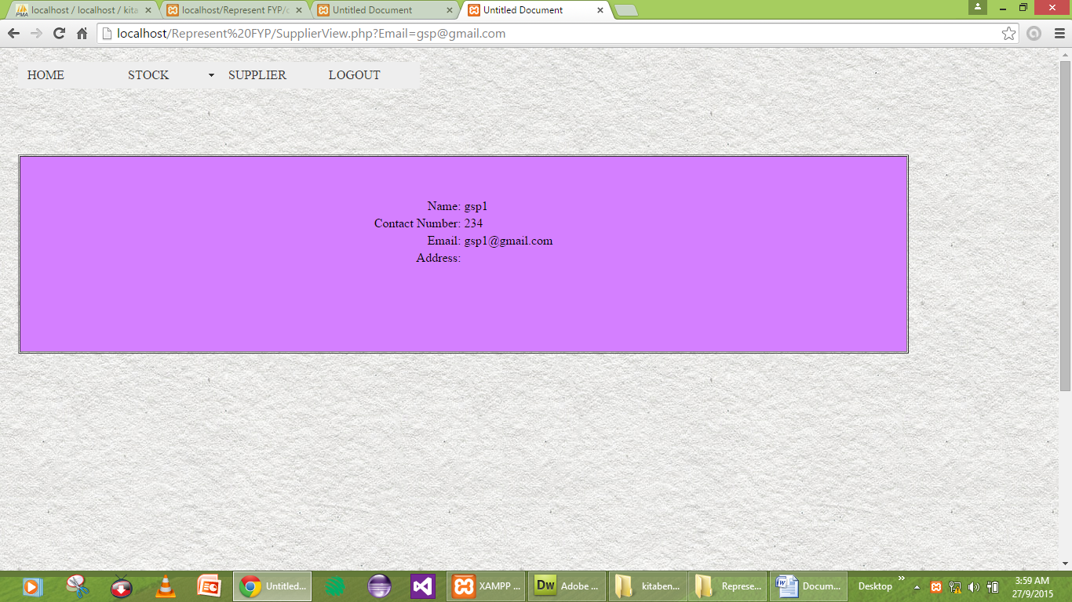

SupplierView

<?php require_once('Connections/Kitabenaconnnection.php'); ?>

<?php

if (!function_exists("GetSQLValueString")) {

function GetSQLValueString($theValue, $theType, $theDefinedValue = "", $theNotDefinedValue = "")

{

if (PHP_VERSION < 6) {

$theValue = get_magic_quotes_gpc() ? stripslashes($theValue) : $theValue;

}

$theValue = function_exists("mysql_real_escape_string") ? mysql_real_escape_string($theValue) : mysql_escape_string($theValue);

switch ($theType) {

case "text":

$theValue = ($theValue != "") ? "'" . $theValue . "'" : "NULL";

break;

case "long":

case "int":

$theValue = ($theValue != "") ? intval($theValue) : "NULL";

break;

case "double":

$theValue = ($theValue != "") ? doubleval($theValue) : "NULL";

break;

case "date":

$theValue = ($theValue != "") ? "'" . $theValue . "'" : "NULL";

break;

case "defined":

$theValue = ($theValue != "") ? $theDefinedValue : $theNotDefinedValue;

break;

}

return $theValue;

}

}

$editFormAction = $_SERVER['PHP_SELF'];

if (isset($_SERVER['QUERY_STRING'])) {

$editFormAction .= "?" . htmlentities($_SERVER['QUERY_STRING']);

}

if ((isset($_POST["MM_update"])) && ($_POST["MM_update"] == "form5")) {

$updateSQL = sprintf("UPDATE supplier SET `Contact Number`=%s, email=%s, address=%s WHERE name=%s",

GetSQLValueString($_POST['Contact_Number'], "int"),

GetSQLValueString($_POST['email'], "text"),

GetSQLValueString($_POST['address'], "text"),

GetSQLValueString($_POST['name'], "text"));

mysql_select_db($database_Kitabenaconnnection, $Kitabenaconnnection);

$Result1 = mysql_query($updateSQL, $Kitabenaconnnection) or die(mysql_error());

}

mysql_select_db($database_Kitabenaconnnection, $Kitabenaconnnection);

$query_Supplier = "SELECT * FROM supplier";

$Supplier = mysql_query($query_Supplier, $Kitabenaconnnection) or die(mysql_error());

$row_Supplier = mysql_fetch_assoc($Supplier);

$totalRows_Supplier = mysql_num_rows($Supplier);mysql_select_db($database_Kitabenaconnnection, $Kitabenaconnnection);

$query_Supplier = "SELECT * FROM supplier";

$Supplier = mysql_query($query_Supplier, $Kitabenaconnnection) or die(mysql_error());

$row_Supplier = mysql_fetch_assoc($Supplier);

$totalRows_Supplier = mysql_num_rows($Supplier);

$query_Supplier = "SELECT * FROM supplier";

$Supplier = mysql_query($query_Supplier, $Kitabenaconnnection) or die(mysql_error());

$row_Supplier = mysql_fetch_assoc($Supplier);

$totalRows_Supplier = mysql_num_rows($Supplier);

?>

<!DOCTYPE html PUBLIC "-//W3C//DTD XHTML 1.0 Transitional//EN" "http://www.w3.org/TR/xhtml1/DTD/xhtml1-transitional.dtd">

<html xmlns="http://www.w3.org/1999/xhtml">

<head>

<meta http-equiv="Content-Type" content="text/html; charset=utf-8" />

<title>Untitled Document</title>

<style type="text/css">

@import url("Home.php.css");

#form1 {

text-align: left;

}

#form1 p {

text-align: center;

}

#form1 p label {

text-align: left;

}

#form1 p label {

text-align: left;

}

#form1 p label {

text-align: left;

}

#form1 p {

text-align: left;

}

body {

background-color: #FFF;

background-image: url(../images%20(4)

.jpg);

background-image: url(Inna/Background/background-pattern-design-56%20(1)

.jpg);

background-image: url(Inna/Background/images%20(9)

.jpg);

background-image: url(003-subtle-light-pattern-background-texture-vol51.jpg);

}

#form1 p label {

text-align: left;

}

#form1 div p label {

text-align: justify;

}

#form1 div p label {

text-align: left;

}

#form1 div p label {

text-align: left;

}

#form1 div p label {

text-align: left;

}

#form1 div p label {

text-align: justify;

}

#form1 div p label {

text-align: left;

}

#form1 div button strong {

color: #009;

}

#MenuBar {

color: #FF80C0;

}

ul {

color: #80FF00;

}

</style>

<link href="Home.php.css" rel="stylesheet" type="text/css" />

<link href="includes/ice/Level1_Arial.css" rel="stylesheet" type="text/css" media="all" />

<link href="../CSS/Level1_Arial.css" rel="stylesheet" type="text/css" />

<style type="text/css">

<!--

a:link {

color: #0FF;

}

#MenuBar {

color: #FF8080;

}

#MenuBar li {

color: #FF8040;

}

#MenuBar li {

color: #FF0;

}

-->

</style>

<script src="SpryAssets/SpryMenuBar.js" type="text/javascript"></script>

<link href="SpryAssets/SpryMenuBarHorizontal.css" rel="stylesheet" type="text/css" />

<link href="SpryAssets/SpryMenuBarVertical.css" rel="stylesheet" type="text/css" />

</head>

<body>

<p><label></label>

<form id="form1" name="form1" method="get" action="Supplier.php">

<div align="center"></div>

</form>

<tr>

<td width="378"><table width="1237" border="0" cellspacing="1" cellpadding="1">

<tr>

<td width="10" height="738"><p>&nbsp;</p>

<p>&nbsp;</p>

<p>&nbsp;</p>

<p>&nbsp;</p>

<p>&nbsp;</p>

<legend></legend>

<legend></legend>

<legend></legend>

<p>&nbsp;</p>

<p>

<legend></legend>

</p>

<p>&nbsp;</p>

<p>&nbsp;</p>

<p>&nbsp;</p>

<p>&nbsp;</p>

<form method="post" name="form4" id="form4">

</form>

<p>&nbsp;</p>

<p>&nbsp;</p>

<p>&nbsp;</p>

<p>&nbsp;</p> <legend></legend></td>

<td width="1220"><ul id="MenuBar1" class="MenuBarHorizontal">

<li><a href="Home.php">HOME</a></li>

<li><a href="#" class="MenuBarItemSubmenu">STOCK</a>

<ul>

<li><a href="insert.php">INSERT</a></li>

<li><a href="update.php">UPDATE</a></li>

<li><a href="view.php">DELETE</a></li>

</ul>

</li>

<li><a href="Supplier.php">SUPPLIER</a></li>

<li><a href="Welcome.php">LOGOUT</a></li>

</ul>

<p>&nbsp;</p>

<p>&nbsp;</p>

<p>&nbsp;</p>

<table width="1135" border="1" cellspacing="1" cellpadding="1">

<tr>

<td width="1127" bgcolor="#D47FFF"><p>&nbsp;</p>

<form method="post" enctype="multipart/form-data" name="form2" id="form2">

</form>

<form action="<?php echo $editFormAction; ?>" method="post" name="form5" id="form5">

<table align="center">

<tr valign="baseline">

<td nowrap="nowrap" align="right">Name:</td>

<td><?php echo $row_Supplier['name']; ?></td>

</tr>

<tr valign="baseline">

<td nowrap="nowrap" align="right">Contact Number:</td>

<td><?php echo $row_Supplier['Contact Number']; ?></td>

</tr>

<tr valign="baseline">

<td nowrap="nowrap" align="right">Email:</td>

<td><?php echo $row_Supplier['email']; ?></td>

</tr>

<tr valign="baseline">

<td nowrap="nowrap" align="right">Address:</td>

<td><?php echo $row_Supplier['address']; ?></td>

</tr>

<tr valign="baseline">

<td nowrap="nowrap" align="right">&nbsp;</td>

<td>&nbsp;</td>

</tr>

</table>

<input type="hidden" name="MM_update" value="form5" />

<input type="hidden" name="name" value="<?php echo $row_Supplier['name']; ?>" />

</form>

<p>&nbsp;</p>

<p>&nbsp;</p></td>

</tr>

</table>

<p>&nbsp;</p>

<p>&nbsp;</p>

<p>&nbsp;</p>

<p>&nbsp;</p>

<p>&nbsp;</p>

<p>&nbsp;</p>

<p>&nbsp;</p>

<p>&nbsp;</p>

<p>&nbsp;</p>

<p>&nbsp;</p>

<p>&nbsp;</p>

<p>&nbsp;</p>

<p>&nbsp;</p>

<p>&nbsp; </p></td>

</tr>

</table>

<div align="center"></div>

<p>&nbsp;</p>

<p>&nbsp;</p>

<form method="post" name="form3" id="form3">

</form>

<p>&nbsp;</p>

<script type="text/javascript">

<!--

var MenuBar1 = new Spry.Widget.MenuBar("MenuBar1", {imgDown:"SpryAssets/SpryMenuBarDownHover.gif", imgRight:"SpryAssets/SpryMenuBarRightHover.gif"});

//-->

</script>

</body>

</html>

<?php

mysql_free_result($Supplier);

?>